Lab 3: Neural Networks and Dataloaders in PyTorch
CSC 492/592: Large Language Models

Background

In this assignment, you will create a linear network using PyTorch and experiment with using Dataloaders on a custom dataset.
Step by Step Guide
Step 1: Installing PyTorch

If you had previously installed PyTorch for another class or for research you can skip this step.

If you are not very familiar with installing software packages and creating environments in Python it is recommended that you go through the “Software Installation Instructions for PyTorch (not required).doc” document on BrightSpace before completing this step.

The installation steps for PyTorch vary slightly depending on the operating system of your computer. For Linux and Mac users the following link gives the instructions for install PyTorch: https://pytorch.org/get-started/locally/

Step 2: Downloading the Dataset

In this assignment we will be working with the Airplanes-Cars-Ships dataset using PyTorch. This dataset contains color images of airplanes, cars and ships. We will create a classifier to classify an image into one of these three categories. The dataset is available as a zip file on BrightSpace. After downloading the zip file, extract it to a folder. It will contain a train and a test folder with three sub folders for images belonging to each category. The number of images in each category for the train and test parts is shown below.
airplanes ships cars
train 1000 1000 1000
test 189 200 193

Step 3: Setting up the Dataset Object

Create a Python application called SimpleClassification as shown below.

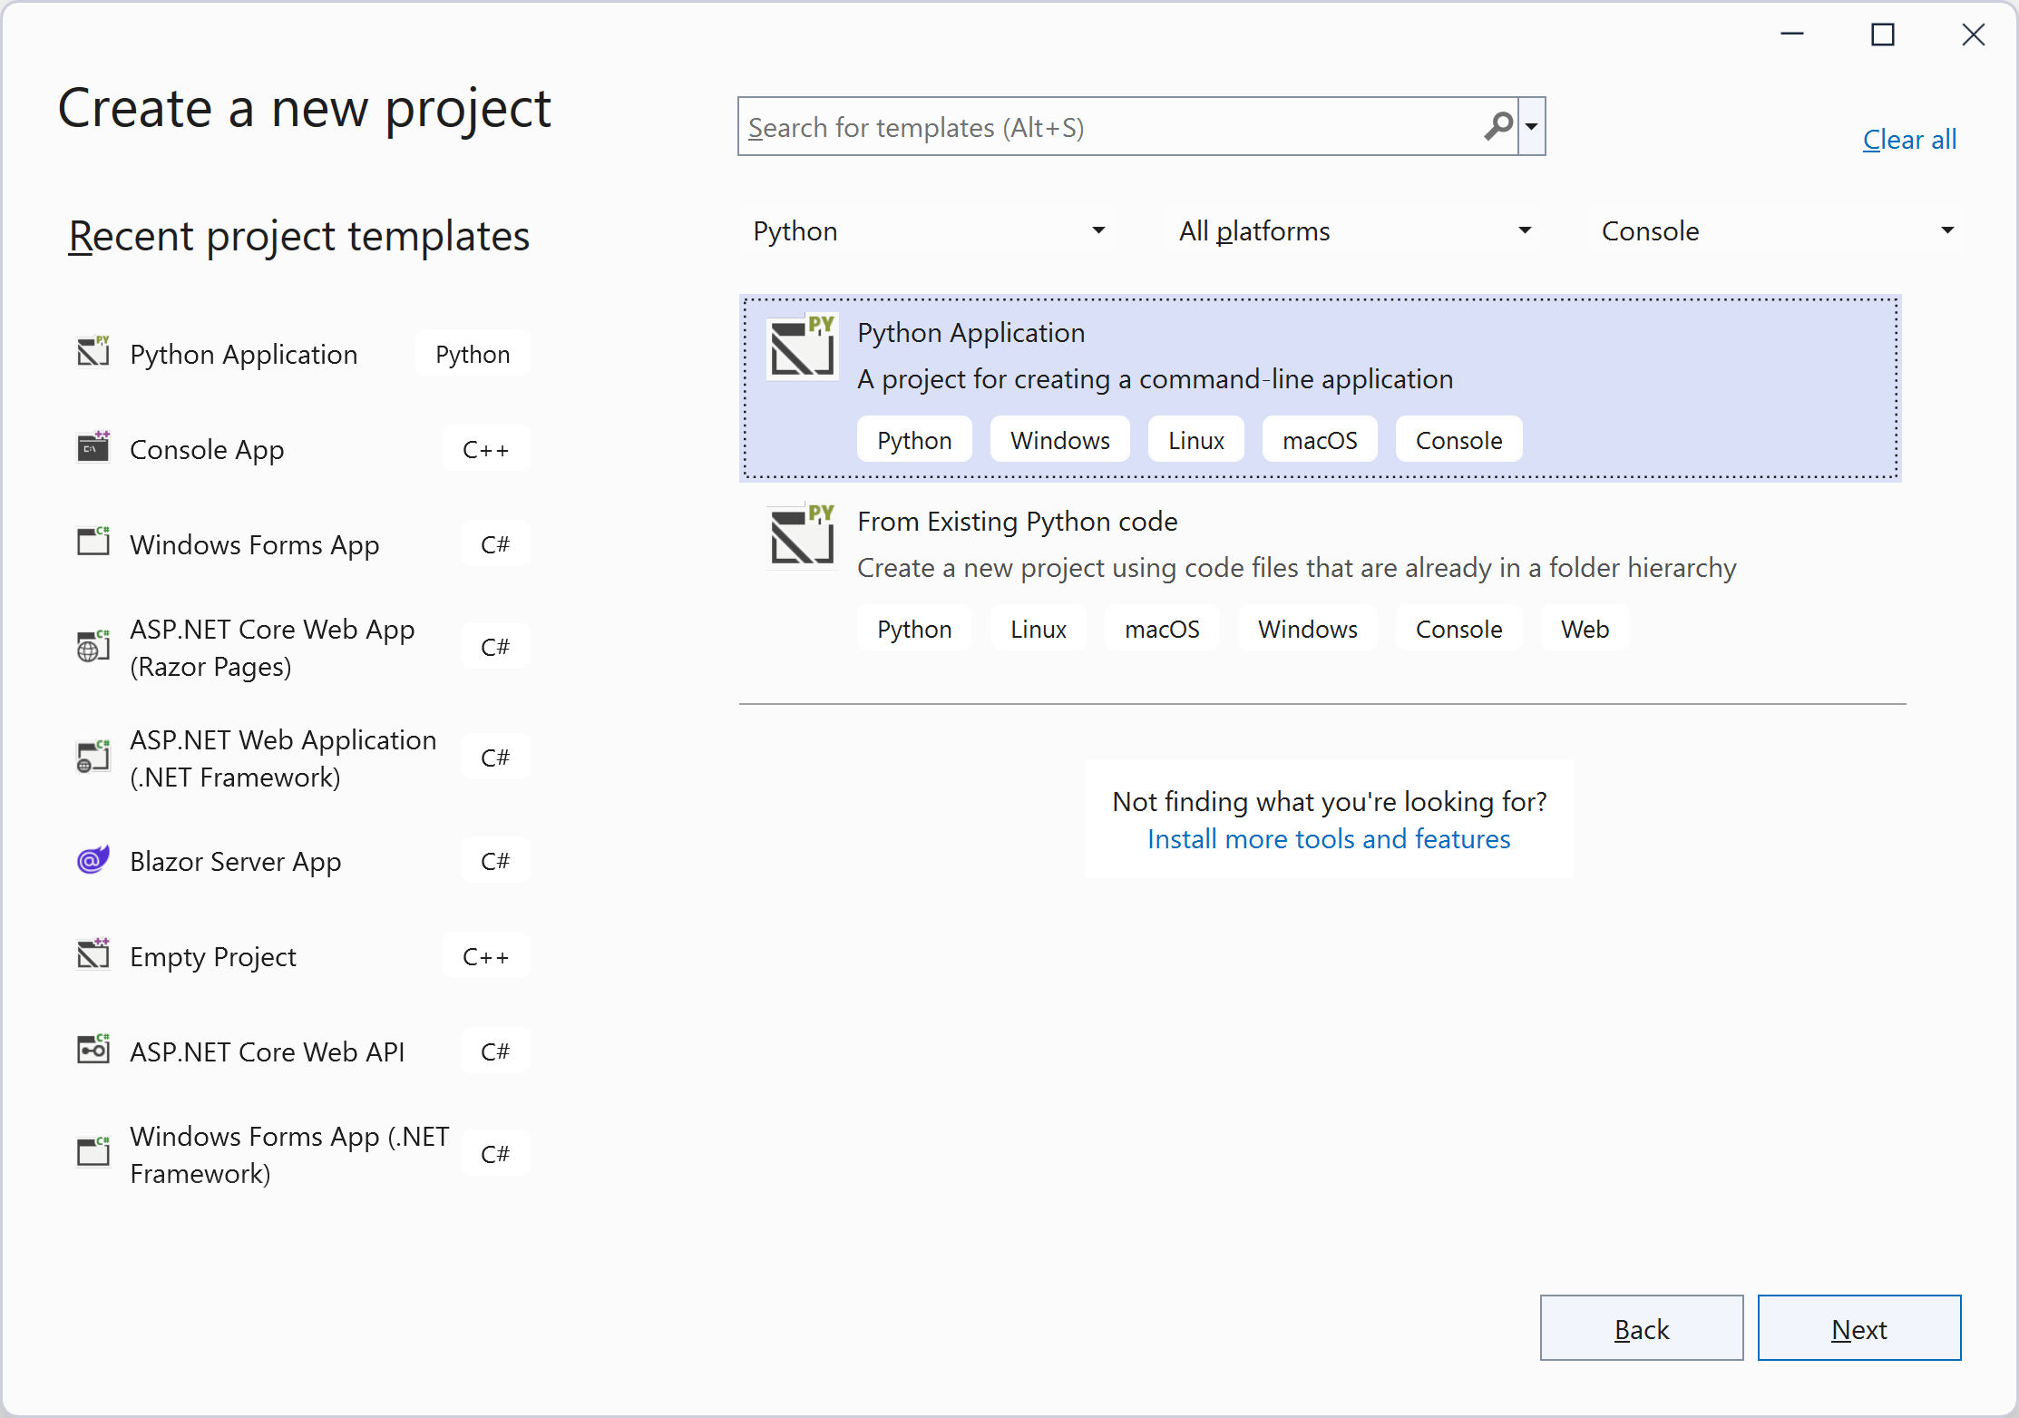
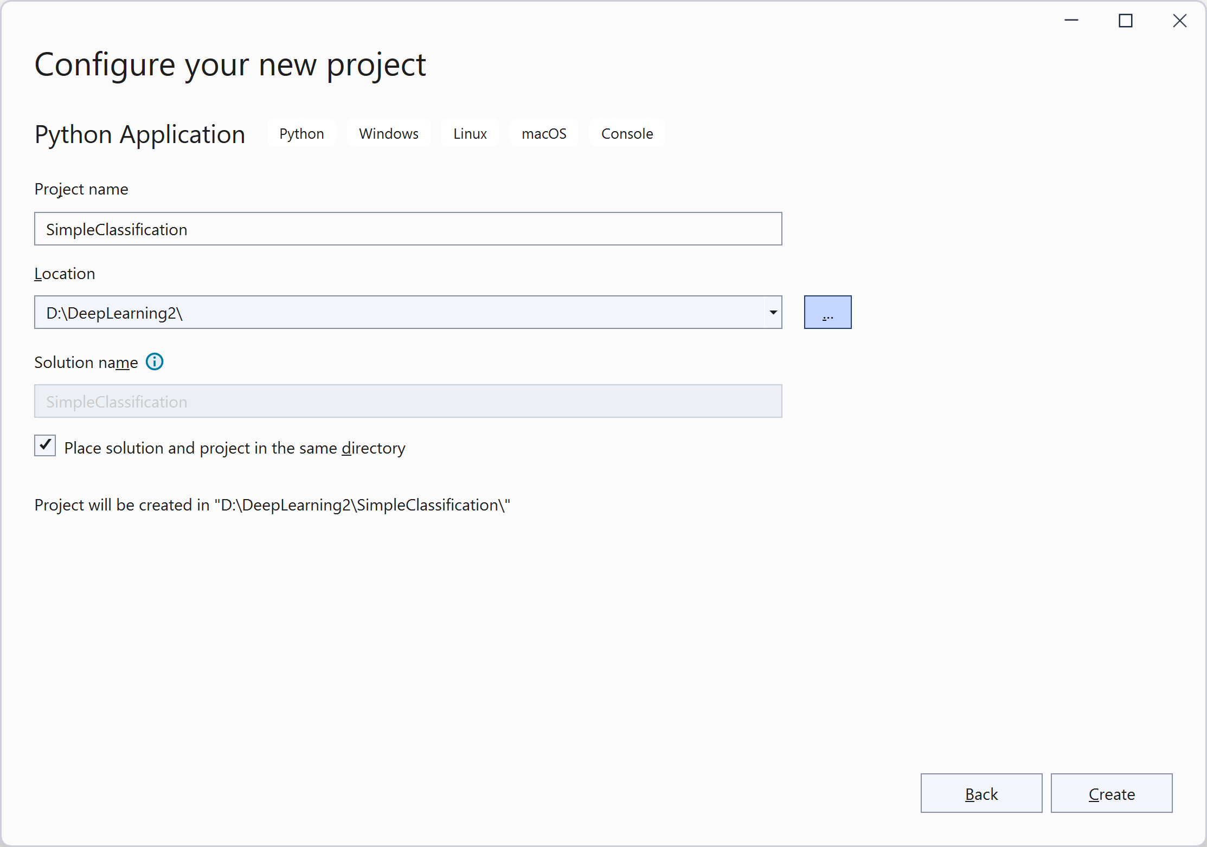
Make sure to add the proper Python environment e.g., pytorch2x for Pytorch for the project.
By right clicking on the project name, add a class to the project called MyDataSet.py with the following code in it:

import torch
import torchvision
import numpy as np
import os
from PIL import Image

class MyDataset(torch.utils.data.Dataset):
# for Airplanes, Cars and Ships dataset
# train or test folders further have subfolders containing images
# for each category

def __init__(self, data_dir, transform=None):
self.data_dir = data_dir
self.transform = transform
self.all_image_paths = []
self.all_labels = []

for planecarship_dir in os.listdir(data_dir): # each category folder
category_path = os.path.join(data_dir, planecarship_dir)
if not os.path.isdir(category_path):
continue
if planecarship_dir == "airplanes":
label = 0
elif planecarship_dir == "cars":
label = 1
elif planecarship_dir == "ships":
label = 2
image_paths = [os.path.join(category_path, f) for f in os.listdir(category_path) if f.endswith('.jpg')]
# list of image filenames for a category, e.g., airplane, car, or ship
labels = [label for i in range(len(image_paths))]
self.all_image_paths += image_paths
self.all_labels += labels
self.num_classes = len(set(self.all_labels))

def __len__(self):
return len(self.all_image_paths)

def __getitem__(self, index):
img_path = self.all_image_paths[index]
label = self.all_labels[index]

img = Image.open(img_path).convert('RGB')
if self.transform is not None:
img = self.transform(img)
return img, label

The purpose of the DataSet object is to access the training and test data. If the total training data is small, we can read all the image pixels and store all images in multi-dimensional tensors in the dataset in the computer memory (RAM) directly. However, if the number of images is large and images happen to be relatively high resolution, then one option is to store the image filenames (with full path info) in the dataset. The following code stores all images in the train or test folders as list of filenames and their labels. It will also apply a transform to the images. Transform usually resizes the image and changes the 0-255 pixel scale to either 0 to 1, or -1 to 1 range.

The __get_item__ function in the DataSet class returns one data item and its label.

Step 4: Setting up the Dataloader

The DataSet is tied to a DataLoader which obtains a batch of data from the dataset and feeds to the training or test loop in the code. Add a file called Utils.py to the project with the following code in it:

import torch
from MyDataSet import MyDataset
import torchvision
import matplotlib.pyplot as plt

def get_train_loader(data_dir, batch_size, transform=None):
dataset = MyDataset(data_dir, transform=transform)
data_loader = torch.utils.data.DataLoader(
dataset,
batch_size=batch_size,
shuffle=True,
num_workers=4,
pin_memory=True,
drop_last=True
)
return data_loader

def get_test_loader(data_dir, batch_size, transform=None):
dataset = MyDataset(data_dir, transform=transform)
data_loader = torch.utils.data.DataLoader(
dataset,
batch_size=batch_size,
shuffle=False,
num_workers=4,
pin_memory=True
)
return data_loader

def plot_images(images, labels):
# normalise=True below shifts [-1,1] to [0,1]
img_grid = torchvision.utils.make_grid(images, nrow=4, normalize=True)
np_img = img_grid.numpy().transpose(1,2,0) # pytorch has the order, c,w,h
# to be able to view an image, we need to change the order and
# put it in width, height, color order
plt.imshow(np_img)
plt.show()

Step 5: Making the Model

Add a class called NetworkLinear with the following code in it.

import torch
import torch.nn as nn
import torch.nn.functional as F

class NetworkLinear(nn.Module):
def __init__(self):
super().__init__()
self.fc1 = nn.Linear(3*224*224, 100)
self.fc2 = nn.Linear(100, 3)
self.sm = nn.Softmax(dim=1)

def forward(self, x):
x = x.view(-1, 3*224*224)
x = F.relu(self.fc1(x))
x = self.sm(self.fc2(x)) # softmax activation on final layer
return x

As you can see, it uses two linear layers. The first one matches its input to the input image size i.e., 3x224x224 and has 100 neurons in it. It uses the Relu activation function.

The second layer has 3 neurons in it as we have three categories of images. The input specification of the second layer has to match the output of the first layer e.g., 100 in our example. We will test the difference between using a linear network versus a CNN based network in the next lab assignment. For this assignment we will only work with standard fully connected feed forward neural networks.

Step 6: The Training Algorithm

Type the following code in the main file, SimpleClassification.py:

import sys
from torchvision import transforms
import torch
import Utils
import torch.optim as optim
from NetworkLinear import NetworkLinear

def main():
device = torch.device("cuda" if torch.cuda.is_available() else "cpu")
data_dir_train = "D:/DeepLearning2/data/Dataset_PlanesCarsShips/train" #TODO: change to your filepath
data_dir_test = "D:/DeepLearning2/data/Dataset_PlanesCarsShips/test" #TODO: change to your filepath
image_transforms = {
"train": transforms.Compose([
transforms.Resize((224, 224)),
transforms.ToTensor(),
transforms.Normalize([0.5, 0.5, 0.5],
[0.5, 0.5, 0.5])
]),
"test": transforms.Compose([
transforms.Resize((224, 224)),
transforms.ToTensor(),
transforms.Normalize([0.5, 0.5, 0.5],
[0.5, 0.5, 0.5])
])
}
# ToTensor converts a PIL Image or numpy.ndarray (HxWxC) in the range [0, 255]
# to a torch.FloatTensor of shape (CxHxW) in the range [0.0, 1.0]
batch_size = 16

num_epochs = 25
train_loader = Utils.get_train_loader(data_dir_train, batch_size, image_transforms["train"])
test_loader = Utils.get_test_loader(data_dir_test, batch_size, image_transforms["test"])
train_iter = iter(train_loader)
images, labels = next(train_iter) # get a batch of data e.g., 16x3x224x224
print(images[0].shape)

Utils.plot_images(images,labels) # plot images

net = NetworkLinear() # create the simple linear model
#net = NetworkCNN() # create the CNN model
loss_criterion = torch.nn.CrossEntropyLoss()
optimizer = optim.SGD(net.parameters(), lr=0.001, momentum=0.9)

running_loss = 0
print_freq = 100
for epoch in range(num_epochs):
for i, data in enumerate(train_loader):
inputs, labels = data
optimizer.zero_grad()
outputs = net(inputs) # forward pass
loss = loss_criterion(outputs, labels)
loss.backward()
optimizer.step()
running_loss += loss.item()
#if i % print_freq == print_freq-1:
print('epoch:',epoch, i+1, running_loss/print_freq)
running_loss = 0

#-----------compute accuracy on trained model-------------
total = 0 # keeps track of how many images we have processed
correct = 0 # keeps track of how many correct images our net predicts
with torch.no_grad():
for i, data in enumerate(test_loader):
images, labels = data
outputs = net(images)
_, predicted = torch.max(outputs.data, 1)
total += labels.size()[0]
correct += (predicted == labels).sum().item()

print("Accuracy: ", correct/total)

if __name__ == "__main__":
sys.exit(int(main() or 0))

Study the above code to see how the training and test loops are set up. Where it says “#TODO: change to your filepath” change the file path to where you saved the dataset (you must make this change in two places in the code).

Step 7: Training the Model

Run the program, you should get a classification accuracy of about 75% when using the linear network as the classifier:

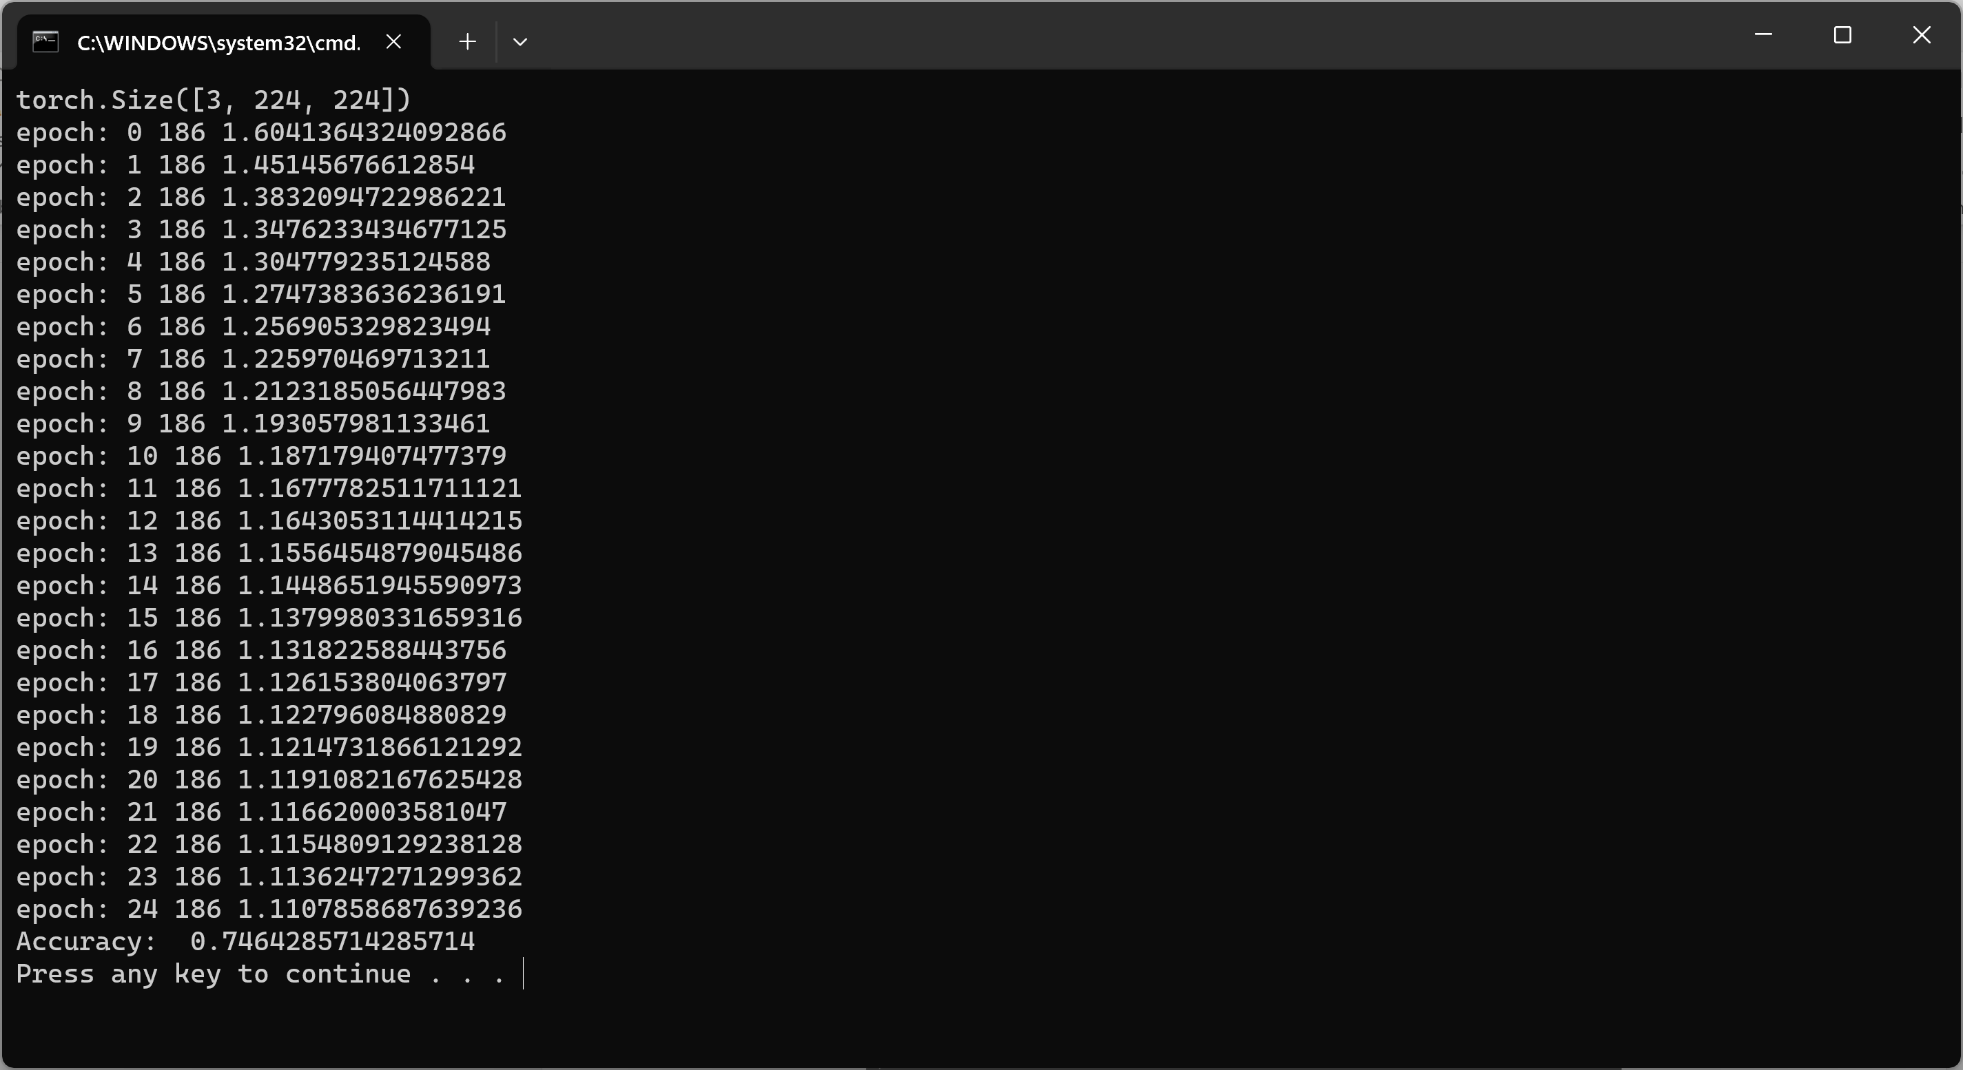

Deliverables
Submit the following two documents on Brightspace:
Deliverable #1: A screenshot of the output of your code.
Deliverable #2: A copy of your code (the .py files).

